ABSTRACT

ATM stands for Automated teller machine. A voice aided is a type of automated teller machine (ATM) that provides audible instructions so that persons who cannot read an ATM screen can independently use the machine. All audible information is delivered privately through a standard headphone jack on the face of the machine or a separately attached telephone handset. Information is delivered to the customer either through pre-recorded sound files or via text-to-speech speech synthesis. A voice aided ATM provide the ability to conduct transactions using both visual and auditory components. Essentially, a talking ATM will provide a means of
Persons with visual impairments to utilize the ATM by making use of audible instructions. While many ATMs today include an audio component that makes use of a speaker system, the voice aided ATM employs the feature of a headphone jack or telephone handset that allows the user to conduct the transaction with a degree of security. This project focuses on simulating a Talking ATM only for blind customers to enhance the quality of service these customers get from bank as it will reduces risk of being defrauded easily as blind customer usually fall victim of fraud.
The paper summarizes how ATMs have matured into a technology application providing financial services to all segments of our society, and the technical functionality behind the provisioning of those services. Voice aided ATM innovation and functionality is explored and a technical model is developed for its integration to existing ATM devices, networks and databases. The paper concludes by outlining potential benefits to customers, banks, government and individuals.

CHAPTER ONE
BACKGROUND OF THE STUDY

1.0 INTRODUCTION
The Automated Teller Machine (ATM) is a self-service machine that dispenses cash and performs some human teller functions like balance enquiry, bills payments, mini statements and so on. ATM transactions are carried out through the use of a debit/credit card which enables the card holder(s) to access and carry out banking transactions without a teller.
Nearly every adult has used an ATM, probably without much thought about who owns and operates it. Many ATMs belong to banks. ATMs are placed not only near or inside the premises of banks, but also in locations such as shopping centers/malls, airports, grocery stores, petrol/gas stations, restaurants, or anywhere frequented by large numbers of people these People typically offer the ATM as a convenience for their customer base and even for non customers. This companies and firms provides after hours access to a host of transactions such as cash withdrawals, deposits, and transfers, but many are placed by independent businesses that operate ATMs for profit.
ATMs are known by various other names including ATM machine, automated banking machine, cash machine and various regional variants derived from trademarks on ATM systems held by particular banks.
On most modern ATMs, the customer is identified by inserting a plastic ATM card with a magnetic stripe or a plastic smart card with a chip that contains a unique card number and some security information such as an expiration date or CVVC (CVV). Authentication is provided by the customer entering a personal identification number (PIN).
Using an ATM, customers can access their bank accounts in order to make cash withdrawals, debit card cash advances, and check their account balances as well as purchase pre-paid mobile phone credit. Banks have become the principal deployers of ATMs. Globally, Banks have become the principal deployers of ATMs. Two reasons for this are that they want to increase their market share, although due to the prevalence of ATMs, it is not likely to be the primary means by which ATMs increase profitability for most banks; or/and above a certain level of operations, the cost of a single transaction performed at an ATM is potentially less than the cost of a transaction conducted from a teller, as ATMs are capable of
Handling more transactions per unit of time than are tellers (Laderman, 1990). In Nigeria the deployment of ATM by banks and its use by bank customers is just gaining ground and has burgeoned in recent times. This has happened especially after the recent consolidation of banks, which has in all probability, made it possible for more banks to afford to deploy ATMs or at least become part of shared networks (Fasan, 2007). The increased deployment of ATMs in the banking sector has made the issue of technology relevance important. ATM services have a history that is less than ten years in Nigeria. At first, they were operated as elitist services designed for those desirous of exclusive service.
The introduction of Automated Teller Machine (ATM) brought succour to Nigerian
Banking environment as long queues in the banking halls began to wane, as most customers opted to transact through that channel. This relief however did not extend to blind and visually impaired customers of the same banks. This ugly scenario prompted the development of a Voice aided or talking specially designed for blind customers of banks. A Talking ATM or voice aided ATM is a type of automated teller machine (ATM) that provides audible instructions so that persons who cannot read an ATM screen can independently use the machine. All audible information is delivered privately through a standard headphone jack on the face of the machine or a separately attached telephone handset. Information is delivered to the customer either through pre-recorded sound files or via text-to-speech speech synthesis.
The situation in Nigeria for blind customers’ of banks has been pathetic as no single financial institution has made provision for a voiced aided ATM. The advent of a Truly Accessible ATM will make persons with disabilities more independent in respect of personal financial matters. It provides complete accessibility to a wheelchair as well as to a visually challenged ATM user.
Our system came as a timely intervention to help customers with visual disadvantage to equally have a fair treatment in banks like their other customer. In this project, we describe a simulated voice aided ATM system, which is truly accessible to blind customers. It has all the features of a real ATM machine like withdrawal of cash, changing of default PIN number, checking of balance etc.
  - AIMS AND OBJECTIVES
This project is aimed at simulating a voiced aided ATM system for blind and visually impaired customers of Nigeria banks that will help them check Balance, change their default PIN, recharge their mobile phone and Withdraw cash with the following objectives:
- To design a robust and friendly user interface voice aided ATM system that is easy to use by blind customer with little assistant from bank staff.
- To provide better banking options to blind customer.
- To provide solution alternatives to the operations inherent in the existing system.
- To review existing literature on voice aided ATM system.
- To examine the relevant of adopting a voice aided ATM system.
- To offer useful recommendations on how do improve on existing ATM systems.

  - STATEMENT OF PROBLEM
It is only in developed countries of the world that nearly all banks deploy Voice aided ATM for it blind customer. Operating by Blind customers is not easy as they are easily defrauded by bank staffs or their close assistance without their knowledge. The processes involved in the process of using ATM has no provision for blind customers and has some negative effects to both customers and banks. These problems necessitated for a prompt action that will require a voice aided or talking ATM system that will bring succour, comfort and security to blind customers.

  - SIGNIFICANCE OF THE THEORY
This project when implemented will directly benefits both the financial institutions using ATM and all its blind customers and will also reduce queue in ATM terminals. It will rebrand the image of Nigerian banking system as fully ICT inclined. This study will in many ways promote good management in Nigeria banking sector.

  - ORGANIZATION OF THE STUDY
This project was covered under five stages:
Chapter 1: Deals with the introduction. The background of the project is discussed. The objectives of the project, statement of problem, its significance, scope, and constraints are pointed out.
Chapter 2: This chapter reviews the related literature on the research work.
Chapter 3: Discusses system Investigation and Analysis. It deals with detailed investigation and analysis of the existing system and problem identification.
Chapter 4: This chapter describes how the new system was designed, how it works and what it needs or requires. This also shows the implementation of the new system with the written program, flowcharts and pseudo codes
Chapter 5: This chapter summarizes, concludes and recommends the research.

  - SCOPE OF THE STUDY
The research work is restricted to ATM operated by financial institution and for only blind customer will cover among other things:
- Changing of customer default PIN.
- Withdrawal of fund.
- Checking of balance.
- Recharging of mobile phones.

1.6 LIMITATIONS OF THE STUDY
Some of the constraints encountered during this project design include the following:
- Financial Constraints: The design was achieved but not without some financial involvements. One had to pay for the computer time. Also the typing and planning of the work has its own financial involvements.
- High programming Technique: The programming aspect of this project posed a lot of problematic bugs that took me some days to solve. Problems such as database connections using visual basic.NET and access database posed a lot of challenges.
- Few Literature Sources: The topic though seems to be a common term; it is not a popular topic to surf from the Internet. It had fewer literature sources.

  - DEFINITION OF TERMS
- ATM : Automated Teller machine (ATM) is a computerized telecommunications device that enables the clients of a financial institution to perform financial transactions without the need for a cashier, human clerk or bank teller.
- SIMULATION: This is the act of imitating the behaviour of a working system or situation or real-world process over time.
- ATM CARD: ATM card is also like magnetic strip card. It is also a data carrier which electronically reads and writes data. ATM cards are mainly a debit card.
- SYSTEM: This is a group of interacting, interrelated or interdependent computers that share a central storage system and various peripheral devices.
- PIN: personal identification number (PIN) is a 4 digit number you choose and use to gain access to your account in an ATM for financial transactions.
- TRANSACTION: This is a legal agreement or activities in banking halls between a customer and the bank. Those activities may include Lodging money into a bank account and withdrawing of money, checking of balance.
- VOICE AIDED ATM: are automatic teller machines that provide the ability to conduct transactions using both visual and auditory components.
- HEADPHONE: These are electro-acoustic transducer for converting electric signals into sounds.
- FRAUD: This is a wrongful or criminal deception intended to result in financial or personal gain.

CHAPTER TWO
LITTERATURE REVIEW
- INTRODUCTION
This chapter present a theoretical framework for the entire study. A review of related literature we considered relevant to simulating a voice aided ATM system. This chapter will cover the history of the conventional ATM and a voice aided ATM. It shall also tell the benefits of ATM to banks, government, society, customers, cardholders and economy. The problems of ATM in Nigeria shall not be left out, components, internal structure of ATM and uses of ATM.

2.1 HISTORY OF ATM
The idea of self-service in retail banking developed through independent and simultaneous efforts in Japan, Sweden, the United Kingdom and the United States. In the USA, Luther George Simjian has been credited with developing and building the first automatic teller machine (which didn't dispense cash).^{[3]} There is strong evidence to suggest that Simjian worked on this device before 1939 while his 132nd patent (US3079603) was first filed on 30 June 1960 (and granted 26 February 1963). The rollout of this machine, called Bankograph, was delayed by a couple of years, due in part to Simjian's Reflectone Electronics Inc. being acquired by Universal Match Corporation.^{[4]} An experimental Bankograph was installed in New York City in 1939 by the City Bank of New York, but removed after 6 months due to the lack of customer acceptance. The Bankograph was an automated envelope deposit machine (accepting coins, cash and cheques) and did not have cash dispensing features.
The first ATM was put into use in 1959 in the Kingsdale Shopping Center in Upper Arlington, Ohio as an automated deposit device. This suburb of Columbus, Ohio created a shopping center where the Galbraith Farm used to be located that also featured the world's first The Limited Store.
In simultaneous and independent efforts, engineers in Japan, Sweden, and Britain developed their own cash machines during the early 1960s. The first of these that was put into use was by Barclays Bank in Enfield Town in North London, United Kingdom, on 27 June 1968. This machine was the first in the UK and was used by English comedy actor Reg Varney, at the time so as to ensure maximum publicity for the machines that were to become main stream in the UK. This instance of the invention has been credited to John Shepherd-Barron of printing firm De La Rue, who was awarded an OBE in the 2005 New Year Honours. His design used paper cheques issued by a teller, marked with carbon-14 for machine readability and security that were matched with a personal identification number.
The Barclays-De La Rue machine (called De La Rue Automatic Cash System or DACS) beat the Swedish saving banks' and a company called Metior's machine (a device called Bankomat) by a mere nine days and Westminster Bank’s-Smith Industries-Chubb system (called Chubb MD2) by a month. The collaboration of a small start-up called Speytec and Midland Bank developed a third machine which was marketed after 1969 in Europe and the USA by the Burroughs Corporation. The patent for this device (GB1329964) was filed on September 1969 (and granted in 1973) by John David Edwards, Leonard Perkins, John Henry Donald, Peter Lee Chappell, Sean Benjamin Newcombe & Malcom David Roe.
Both the DACS and MD2 accepted only a single-use token or voucher which was retained by the machine while the Speytec worked with a card with a magnetic strip at the back. They used principles including Carbon-14 and low-coercivity magnetism in order to make fraud more difficult. The idea of a PIN stored on the card was developed by a British engineer working on the MD2 named James Goodfellow in 1965 (patent GB1197183 filed on 2 May 1966 with Anthony Davies). The essence of this system was that it enabled the verification of the customer with the debited account without human intervention. This patent is also the earliest instance of a complete “currency dispenser system” in the patent record. This patent was filed on 5 March 1968 in the USA (US 3543904) and granted on 1 December 1970. It had a profound influence on the industry as a whole. Not only did future entrants into the cash dispenser market such as NCR Corporation and IBM licence Goodfellow’s PIN system, but a number of later patents reference this patent as “Prior Art Device”.
After looking first hand at the experiences in Europe, in 1968 the networked ATM was pioneered in the US, in Dallas, Texas, by Donald Wetzel, who was a department head at an automated baggage-handling company called Docutel. Recognised by the United States Patent Office for having invented the ATM network are Fred J. Gentile and Jack Wu Chang, under US Patent # 3,833,885. On September 2, 1969, Chemical Bank installed the first ATM in the U.S. at its branch in Rockville Centre, New York. The first ATMs were designed to dispense a fixed amount of cash when a user inserted a specially coded card. A Chemical Bank advertisement boasted "On Sept. 2 our bank will open at 9:00 and never close again." Chemical's ATM, initially known as a Docuteller was designed by Donald Wetzel and his company Docutel. Chemical executives were initially hesitant about the electronic banking transition given the high cost of the early machines. Additionally, executives were concerned that customers would resist having machines handling their money. In 1995, the Smithsonian National Museum of American History recognised Docutel and Wetzel as the inventors of the networked ATM.
The first modern ATMs came into use in December 1972 in the UK; the IBM 2984 was designed at the request of Lloyds Bank. The 2984 CIT (Cash Issuing Terminal) was the first true Cashpoint, similar in function to today's machines; Cashpoint is still a registered trademark of Lloyds TSB in the UK. All were online and issued a variable amount which was immediately deducted from the account. A small number of 2984s were supplied to a US bank. A couple of well known historical models of ATMs include the IBM 3624 and 473x series, Diebold 10xx and TABS 9000 series, NCR 1780 and earlier NCR 770 series.
In Nigeria, the first bank to introduce ATM was the Moribund Societe Generale (SGBN) in 1990. The trade name for SGBN’s ATM was “Cash Point 24”. One of the first generation banks then, First Bank Plc came on stream with their own ATM in December 1991, a year behind SGBN. They also gave a trade name “FIRST CASH” to their ATM. While that of SGBN was the drive-in-system that of the First Bank ATM was through-the-wall.
The world’s first Voice aided or talking ATM for the blind was an NCR machine unveiled by the Royal Bank of Canada on October 22, 1997 at a bank branch on the corner of Bank Street and Queen Street in Ottawa, Ontario. The talking ATM was a result of concerns Chris and Marie Stark, two blind customers, raised with the bank beginning in 1984. Their concerns turned into a discrimination complaint with the Canadian Human Rights Commission in 1991. The machine was manufactured by NCR and adapted by Ottawa based T-Base Communications at a cost of about $500,000 Canadian dollars. (Wikipedia.com)
2.2 TYPES OF ATM
There are five types of ATM these are:
ONSITE ATM -Is situated either within the branch premises or in very close proximity of the branch.
OFFSITE ATM- Is not situated within the branch premises but is located at other places, such as shopping centres, airports, railways station and petrol stations.
WORKSITE ATM -Is located within the premises of an organisation and is generally meant only for the employees of the organisation.
CASH DISPENSER -Allows only cash withdraws, balance enquiry and mini statement requests, cash dispenser(CD) is generally used as the ATM, however the customer cannot deposit cash or cheques in a cash dispenser , whereas, they can use ATM both for cash withdraw and for depositing cash or cheque.
MOBILE ATM - refers to an ATM that moves in various areas for the customers. Few private banks have introduced ATM on wheels.

2.3 HOW ATM WORKS

Name of Bank
1
2
3
4
5
6
7
8
9
0
CanceL
Clear
Enter
Insert Card
Back to Main Menu
ATM Simulator Interface Design
Most ATMs are connected to interbank networks, enabling people to withdraw and deposit money from machines not belonging to the bank where they have their account or in the country where their accounts are held (enabling cash withdrawals in local currency). Some examples of interbank networks include PULSE, PLUS, Cirrus, Interac, Interswitch, STAR, and LINK.
ATMs rely on authorization of a financial transaction by the card issuer or other authorizing institution via the communications network. This is often performed through an ISO 8583 messaging system.
ATMs typically connect directly to their host or ATM Controller via either ADSL or dial‐up mo
dem over a telephone line or directly via a leased line. Leased lines are preferable to POTS lines because they require less time to establish a connection. Leased lines may be comparatively expensive to operate versus a POTS line, meaning less‐trafficked machines will usually rely on a dial‐up modem. That dilemma may be solved as high‐speed Internet VPN connections become more ubiquitous. Common lower‐level layer communication protocols used by ATMs to communicate back to the bank include SNA over SDLC, TC500 over Async, X.25, and TCP/IP over Ethernet. In addition to methods employed for transaction security and secrecy, all communications traffic between the ATM and the Transaction Processor may also be encrypted via methods such as SSL. (Aimee Leeper)When an ATM transaction is processed the machine makes contact to begin the authorization process. The ATM machine has a TID (terminal ID number). This is the number that identifies it uniquely within the processing system. This is how the networks allow the transaction to be completed. This TID along with other identifying information lets the cardholder's bank know that the transaction is taking place on that particular ATM. Now the ATM can connect to the networks through our processing center and then to the cardholder’s bank. If there are sufficient funds in the ATM cardholders account for the withdrawal request, the transaction will be completed. Once transactions are approved the ATM receives the authorization and dispenses the cash requested. The ATM can also be used if someone just wants to check their account balance or transfer funds before or after withdrawing cash. There is typically no surcharge placed on non‐cash withdrawal transactions. ( Mosabber Hossain,2006)
2.4 ALTERNATIVE USES OF ATM
Although ATMs were originally developed as just cash dispensers, they have evolved to include many other bank-related functions. In some countries, especially those which benefit from a fully integrated cross-bank ATM network (e.g.: Multibanco in Portugal), ATMs include many functions which are not directly related to the management of one's own bank account, such as:
- Deposit currency recognition, acceptance, and recycling.
- Paying routine bills, fees, and taxes (utilities, phone bills, social security, legal fees, taxes, etc.)
- Printing bank statements.
- Updating passbooks.
- Loading monetary value into stored value cards.
- Adding pre-paid cell phone / mobile phone credit.
- Purchasing
  - Postage stamps.
  - Lottery tickets
  - Train tickets
  - Concert tickets
  - Movie tickets
  - Shopping mall gift certificates.
  - Gold - "In London last week [in 2011] some smart businessmen launched the country’s first gold ATM. Stick in your debit card or some cash, and the machine will swap your plastic or paper money for a small bar of the real stuff.
- Games and promotional features.
- Fastloans.
- CRM at the ATM.
- Donating to charities.
- Cheque Processing Module.
- Paying (in full or partially) the credit balance on a card linked to a specific current account.
- Transferring money between linked accounts (such as transferring between checking and savings accounts).
Increasingly banks are seeking to use the ATM as a sales device to deliver pre approved loans and targeted advertising using products such as ITM (the Intelligent Teller Machine) from Aptra Relate from NCR. ATMs can also act as an advertising channel for companies to advertise their own products or third-party products and services.
In Canada, ATMs are called guichets automatiques in French and sometimes "Bank Machines" in English. The Interact shared cash network does not allow for the selling of goods from ATMs due to specific security requirements for PIN entry when buying goods.^{[66]} CIBC machines in Canada are able to top-up the minutes on certain pay as you go phones.
2.5 BENEFITS OF ATM
To the Banks:
- ATMs reduce queues in banking halls.
- ATMs save banks cost of hiring tellers by automating many “Teller” transactions.
- ATM enables banks to re-design branches into more sophisticated customer services and sales outlet.

To the customers or cardholders:
- ATM allows customer withdraw cash outside of banking hours, enabling retail cash purchases around the clock.
- ATMs saves customers transport costs and time by bringing self-service banking into convenient, non-branch locations nearer to where they live work and shop.
- ATMs can help customer or cardholders monitor their bank accounts outside of bank hours through balance enquiries.
To the Economy:
- ATMs distribute and recycle the bulk of banknotes in modern economies.
- ATMs are a critical channel in the whole cash and spending cycle underpinning the consumer economy.
- ATMs make cross-border remittances possible for millions of the world’s migrant workers.
To the Government:
- ATMs provide a convenient outlet for public benefit and welfare payments.
- ATMs assist with electronic payroll in both the private and public sectors by supplying employees with a means to draw cash from their salaries deposited directly into their bank accounts. (Aimee Leeper, 2007)

2.6 PROBLEMS OF ATM USAGE IN NIGERIA
Problem of ATM usage among it customer in our clime may includes the following:
1.) INSUFFICIENT DISBURSABLE FUNDS
An ATM card has at one time or the other witnesses the lack of sufficient funds at a service point. This usually happens when a customer for example wants to withdraw cash but the disbursable cash left in the ATM is not enough and may result in outright rejection of card.
At such instances, one may notice the attempt of the machine trying to activate a process that dispenses cash but for which no sufficient cash is available to complete the task. When this occurs, one of these may result
a. Cards may be withheld.
b. Non disbursable cash is deducted from an account.
c. Outright rejection of card.

2.) REQUIRED DENOMINATIONS NOT DISPENSED:

Another source of concern in the implementation of ATM is lack of denomination required by customers at a particular point in time. Sometime customer with little balance in his/her account may want to draw some denominations that are not available in the system.

- STEALING OF CARD/PIN NUMBER:

Stealing of cards/PIN number is one of the main security risks associated with ATM implementation in our environment. Incidences of card stealing have been reported . PINs have also been reported stolen through finger reading by people watching customers type in their Personal Identification Numbers (PINs).

- INADEQUATE POWER SUPPLY:

Power is still a source of major challenge facing our country. ATM machines need power to operate. It is therefore imperative that the systems is kept running 24/7 uninterrupted if the gains of implementing them is to be achieved.( Sunday Adewumi, 2008)

2.7 ATM FRAUD.
A Report on Global ATM Frauds (2007) identified the following types of ATM Frauds:
(a) Shoulder Surfing: This is a fraud method in which the ATM fraudster use a giraffe method to monitor the information the customer keys in into the ATM machine unknown to the customers.
(b) Lebanese Loop: This is a device used to commit and identify theft by exploiting Automated Teller Machine (ATM). Its name comes from its regular use among Lebanese financial crime perpetrators, although it has now spread to various other international crime groups.
(c) Using Stolen Cards: This is a situation in which the ATM card of a customer is stolen and presented by a fake presenter.
(d) Card Jamming: Once the ATM card is jammed, fraudster pretending as a genuine
Sympathizer will suggest that the victim re-enter his or her security code. When the card holder ultimately leaves in despair the fraudster retrieves the card and enters the code that he has doctored clandestinely.
(e) Use of Fake Cards: Fraudsters use data collected from tiny cameras and devices called ‘skimmers’ that capture and record bank account information.
(f) Duplicate ATMs: The fraudsters use software which records the passwords typed on those machines. Thereafter duplicate cards are manufactured and money is withdrawn with the use of stolen Passwords. Sometimes such frauds are insiders’ job with the collusion of the employees of the Company issuing the ATM Cards.
(g) Card Swapping: This is a card theft trick whereby a fraudster poses as a “Good Samaritan” after forcing the ATM to malfunction and then uses a sleight of hand to substitute the customer’s card with an old bank card. As the customers is endlessly trying to push the card through, the fraudster offer assistance by pretending to help the customer push through the card.
(h) Diversion.
(i) ATM Burglary. (Johnson Olabode Adeoti,2011)

2.8 COMPONENTS OF ATM
Card Reader:
Customer inserts their card in it when there is written “Please Insert your card” on the screen.
Keypad:
Use for PIN code input, choices, amount of money etc as the input to the ATM machine.
Display Screen:
This screen shows all the instructions or options for the customers’ convenience.
Screen Buttons: When options are given on the screen one user can choose any of the options accordingly by the use of button on left or right side of the screen. These buttons select the option from the screen.
Cash Dispenser:
Withdrawal money is given by this slot.
Deposit Slot:
To deposit money this slot is use.
Speaker:
Speaker provides the facilities to the customer by giving auditory feedback.

2.9 HARDWARE AND SOFTWARE PARTS OF ATM
2.9.1 HARDWARES
An ATM is typically made up of the following hardware devices:
- CPU (to control the user interface and transaction devices).
- Magnetic and/or Chip card reader (to identify the customer).
- PIN Pad (similar in layout to a Touch tone or Calculator keypad), often manufactured as part of a secure enclosure.
- Secure crypto processor, generally within a secure enclosure.
- Display (used by the customer for performing the transaction).
- Function key buttons (usually close to the display) or a Touchscreen (used to select the various aspects of the transaction).
- Record Printer (to provide the customer with a record of their transaction).
- Vault (to store the parts of the machinery requiring restricted access).
- Housing (for aesthetics and to attach signage to).
- Sensors and Indicators.
2.9.2 SOFTWARES
Today the vast majority of ATMs worldwide use softwares like Microsoft Windows OS, primarily Windows XP Professional or Windows XP Embedded. A small number of deployments may still be running older versions of Windows OS such as Windows NT, Windows CE, or Windows 2000.
There is a computer industry security view that general public desktop operating systems have greater risks as operating systems for cash dispensing machines than other types of operating systems like (secure) real-time operating systems (RTOS). RISKS Digest has many articles about cash machine operating system vulnerabilities.
Linux is also finding some reception in the ATM marketplace. An example of this is Banrisul, the largest bank in the south of Brazil, which has replaced the MS-DOS operating systems in its ATMs with Linux. Banco do Brazil is also migrating ATMs to Linux.
Common application layer transaction protocols, such as Diebold 91x (911 or 912) and NCR NDC or NDC+ provide emulation of older generations of hardware on newer platforms with incremental extensions made over time to address new capabilities, although companies like NCR continuously improve these protocols issuing newer versions (e.g. NCR's AANDC v3.x.y, where x.y are subversions). Most major ATM manufacturers provide software packages that implement these protocols. Newer protocols such as IFX have yet to find wide acceptance by transaction processors.
2.9.3 VOICE AIDED OR TALKING ATM AND IT FEATURES
Talking ATMS are automatic teller machines that provide the ability to conduct transactions using both visual and auditory components. Essentially, a talking ATM will provide a means of persons with visual impairments to utilize the ATM by making use of audible instructions. While many ATMs today include an audio component that makes use of a speaker system, the talking ATM employs the feature of a headphone jack or telephone handset that allows the user to conduct the transaction with a degree of security.
The great advantage of the talking ATM is that it makes it possible for a wider range of users to conduct business utilizing an ATM. For many people, a visual display is sufficient to handle the basic banking functions associated with the device. However, persons who have vision issues and cannot read an ATM screen would either have to forego usage or entrust another person to assist them in making a transaction. With a talking ATM, visual impairment ceases to be an obstacle in making use of the automatic teller machine.
By providing a headphone jack that will work with most standard stereo headphones, the talking ATM makes it possible for persons to plug into the system and hear a series of audible communications that allow the user to indicate the type of transaction desired. Once the user has selected the transaction type, audible prompts walk the user through the process. Often, the technology currently in use with a talking ATM will involve either pre-recorded sound files or equipment that is configured to manage a text to speech synthesis process.
While the talking ATM is not yet a universal offering, a growing number of banks are installing this type of ATM at their branches. Because advances in technology are making the talking ATM more cost efficient for companies that provide remote access to bank accounts via ATMs set up in supermarkets and airport terminals. Some experts predict that within a decade, the talking ATM will be the standard for all automatic teller machines. (Malcolm Tatum, 2011).
A VOICE AIDED OR TALKING ATM HAS THE FOLLOWING FEATURES:
- Physical accessibility facilities like ramp, floor guidance, door size, height and reach, floor space, railings, etc. for a wheelchair ATM user.
- A visually challenged person can independently operate an ATM machine for Cash Withdrawal, Balance Enquiry and PIN change ATM operations.
- Braille signages are put on the ATM machine for locating ATM parts like card slot, cash dispenser, receipt printer, etc.
- Talking ATM mode enabled through insertion of a headphone in an audio jack of ATM machine.
- Use of ATM keypad matrix to do complete ATM operation. This functionality is similar to an IVR wherein you use only number options to select different options.
- A keypad is a standard telephone matrix keypad with a raised dot on the key number 5 which is a universal design. A visually challenged user use this key 5 as a reference key and can easily locate other number keys.
- Keypad buttons orientation is provided so that a visually challenged person can easily find buttons like Cancel, Clear and Enter. Also these three function keys have distinct raised symbols so that a visually challenged user can feel and press a correct key. Keypad number pressed is supported by a beep sound.
- Important features a visually challenged user can choose in the beginning of his ATM operation are language choice, volume control, hide or display screen and orientation to the ATM machine.
- Complete screen text and audio synchronization is provided.
- ATM screens with white text on red background, bigger font size of text and menu selection options with white text on blue background are following the accessibility norms for low vision persons. (Union bank of India website).
CHAPTER THREE
SYSTEM DESIGN
- INTRODUCTION
Existing systems and problems is the main basics of most computer related systems. These systems and its procedure are always open for scrutiny before a whole new design and development effort takes place.
System analysis in simulating a voice aided ATM can only be done, if the outcome of feasibility is positive before proceeding to prepare list of requirements for the new system.
Our analysis in this project shows that the existing ATM is far from being acceptable for all kind of people in our society. This clearly shows that the physically challenges especially the blind has business in the current ATM being deploy in Nigerian banks.
This chapter deals with the various methods used in collecting data, designing and developing the new system, the input format, the database structure, sequence and flowchart diagram.
3.1 RESEARCH METHODOLOGY
From the study, the required system of the operation was specified during the design and development phase .During the course of this project, some methods or approach in the data collection were
  - Personal interview
  - Observation.
  - Record inspection.

3.2 SYSTEM DESIGN
The system design work for acquiring a complete, efficient, reliable Voice aided ATM system involves series of major activities or procedures. Designing these systems involves specifying the input, output and processing step for new system.
3.2.1 INPUT AND OUTPUT FORMAT
It is necessary to consider what is required from the system before one set about designing it for the aim of this research, considerations would be given to:
- Data collection and validation media used.
- Types of input/output media used.
- Design of input/output layout.
- DATA COLLECTION AND VALIDATION MEDIA USED: primary and secondary form of data collection and validation method were used to ensure the effectiveness of this work while collecting data, oral interview were conducted among the management of the Banks as well as the staff. On the other hand, observations were taken into consideration on how the operation was done. More so, record inspections were carried out, such as studying the banks form and ATM related form.
B.) TYPES OF INPUT/OUTPUT MEDIA USED: computer while executing a program expects input. From the user input device and the user also needs hard copy as an output from the output device for the purpose of the research work, the input and output media use were, keyboard, visual display unit and printer respectively.
C.) DESIGN OF INPUT /OUTPUT FORMAT

INPUT FORMAT
    - CHANGE PIN NUMBER FORM

ENTER OLD PIN

NEW PIN NUMBER

CONFIRM NUMBER

CUSTOMER FULLNAME

ACCOUNT NUMBER

ii) FUND TRANSFER FORM

RECIPIENT ACCOUNT NUMBER

AMOUNT TO TRANSFER

OUTPUT FORMAT
- CHANGE PIN NUMBER FORM
ENTER OLD PIN : 9932

NEW PIN NUMBER : 1023

CONFIRM NUMBER : 1023

CUSTOMER FULLNAME : AUSTIN, UDUAK ESSIEN

ACCOUNT NUMBER : 2346866564

ii) FUND TRANSFER FORM

RECIPIENT ACCOUNT NUMBER : 23785564332

AMOUNT TO TRANSFER : 806400 RUPEES

3.3 DATABASE DESIGN
DATABASE NAME: ATM
TABLE NAME: CUST_DATA
FIELD NAME | DATA TYPE | FIELD SIZE
fullname | Text | 33
sex | Text | 5
marital_status | Text | 10
phone | Text | 15
lga | Text | 20
State | Text | 20
Occupation | Text | 15
dateopen | Date/time | 10
account_num (pk) | Text | 10
initial_deposit | Text | 22
Balance | Text | 22
pin | Text | 4
TABLE NAME: PIN
FIELD NAME | DATA TYPE | FIELD SIZE
Pin | Text | 4
serial_num (pk) | Text | 11
status | Text | 5

TABLE NAME: TRANSACTION
FIELD NAME | DATA TYPE | FIELD SIZE
date_transaction | Text | 12
account_num (fk) | Text | 10
pin | Text | 4
amtwithdraw | Text | 22
Trans_id | AutoNumber | 4
balance | Text | 22

3.4 USE CASE MODELING FOR ATM SYSTEMS
In an automated teller machine shown in Figure 1, the Bank Customer can withdraw cash from an account, transfer funds between accounts, or deposit funds to an account. These correspond to specific goals that the actor has in using system.

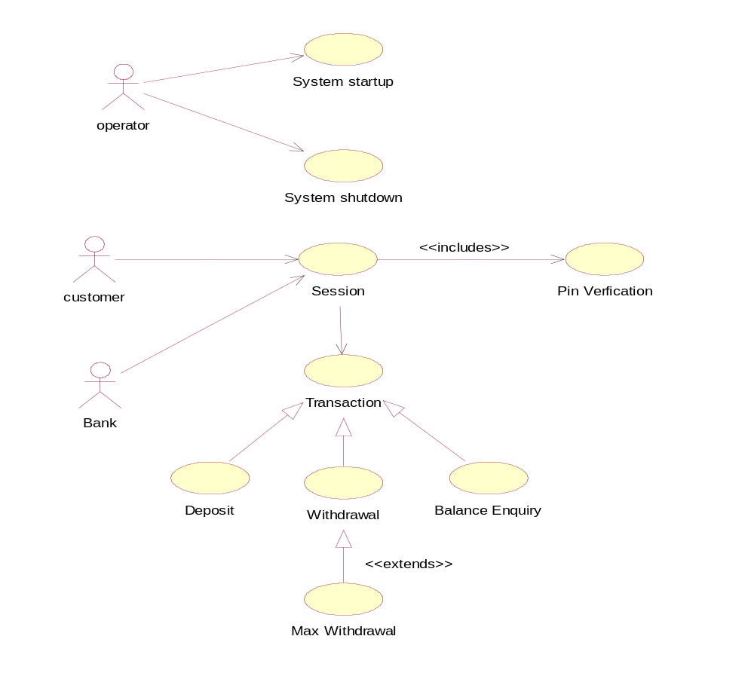
Use Case Diagram for ATM System

Withdrawal Transaction Use Case
A withdrawal transaction asks the customer to choose a type of account to withdraw from. The system verifies that it has sufficient money on hand to satisfy the request before sending the transaction to the bank.
Pre-conditions:
The customer must have a valid ATM card and PIN.
Post-conditions:
The customer receives the cash amount that he wanted to withdraw, with a receipt, if indicated. The customer’s account balance is updated in the system.

Specifications:
Primary Actor: Customer
Stakeholders: - Customer: Wants quick, accurate withdrawal of cash
- Bank: Wants to give fast, accurate and reliable service to the customer
- Bank that owns ATM: (If not the same as the customer’s bank): Wants to charge the customer the correct amount of surcharge on the withdrawal.
- ATM Administrator: Wants to ensure that the ATM always has sufficient cash for a predicted number of withdrawals per day.
Normal flow of events:
1. The customer inserts ATM card into the ATM machine and enters PIN.
2. The system validates the ATM card and PIN
3. The customer selects the ‘Cash Withdrawal’ option from the Options Menu.
4. The system prompts customer to enter the amount of cash that he or she wants to withdraw.
5. The customer enters a cash amount and selects the ‘Submit’ option on the Cash Withdrawal Screen.
6. The system validates the amount entered; checks account balance and that the machine has enough cash
For the transaction, and asks the customer if he or she wants a receipt for the transaction.
7. The customer selects ‘Yes’ on the Receipts Screen.
8. The system ejects the ATM card, provides the cash, prints the receipt and updates the account balance of the customer in the system.
Alternate flow of events:
1. The customer has entered invalid PIN; the system prompts the customer to enter a valid PIN.
2. If ATM card is not compatible-The system rejects the ATM card and displays an error message.
3. The customer has entered an amount that exceeds the withdrawal limit.
4. The system rejects the transaction & displays an error message.

Deposit Transaction Use Case
A deposit transaction asks the customer to choose a type of account to deposit to. If the transaction is approved, the machine accepts an envelope from the customer containing cash and/or checks before it issues a receipt.
Pre-conditions:
The customer must have a valid ATM card and PIN.
Post-conditions:
The customer receives the receipt of cash amount/cheque that he has deposited. The customer’s account balance is updated in the system.

Specifications:
Primary Actor:
- Customer
Stakeholders:
- Customer: Wants quick, accurate withdrawal of cash
- Bank: Wants to give fast, accurate and reliable service to the customer
- ATM Administrator: Wants to ensure that the ATM always has sufficient cash for a predicted number of withdrawals per day.

3.5 SEQUENCE DIAGRAM OF ATM
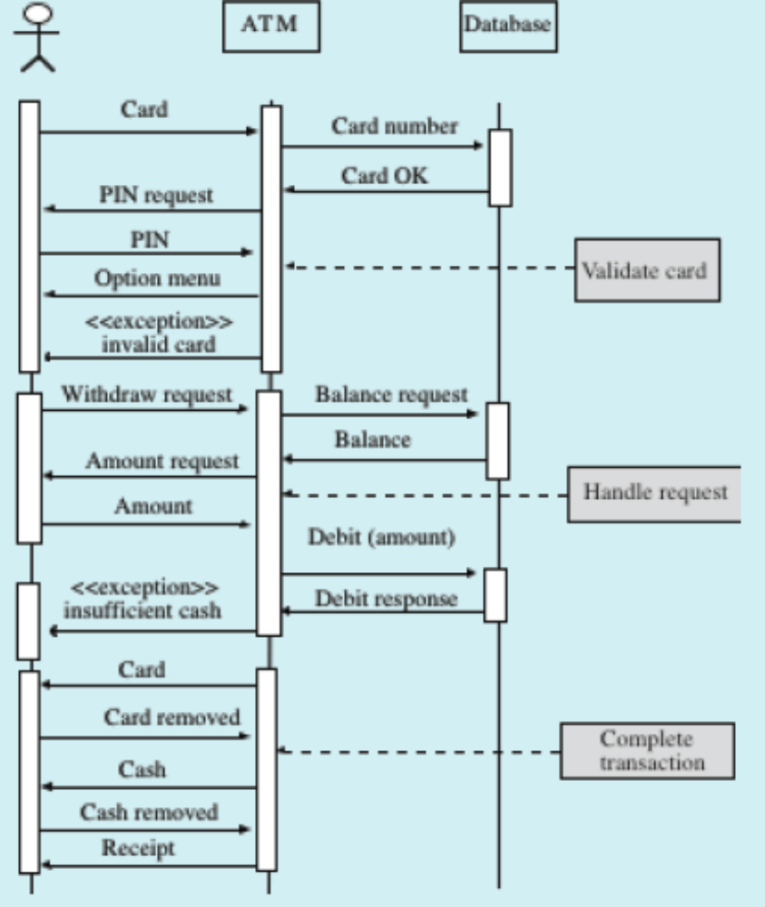
3.6 ACTIVITY DIAGRAM OF ATM
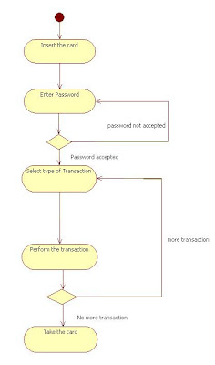

3.7 PSEUDOCODE: ATM
Approach ATM
Repeat
Output ‘Select option’
Output ‘1) Make withdrawal’
Output ‘2) Make deposit ’
Output ‘3) Show balance ’
Output ‘4) Quit ‘
Input Option
If option = deposit then
Output = ‘Enter amount to deposit’
Input amount
Balance balance + amount
If option = withdraw then
Output ‘Enter amount to withdraw’
Input amount
Balance balance - amount

Output ‘balance is balance’
Until option = quit
Stop

CHAPTER FOUR
SYSTEM IMPLEMENTATION
- CHOICE OF PROGRAMMING LANGUAGE
This system “SIMULATING A VOICE AIDED ATM FOR THE BLIND” is window base system design and developed using Microsoft visual basic.Net 2008 as the front end programming language and Microsoft access as the backend. The reason behind the choice of my tools is because visual basic.net 2008 is fully object oriented, has classes and control to make my graphical user interface simple to operate. Also vb.net 2008 makes connection to any database simple .vb.net 2008 is platform independent and support language interoperability with various .Net compliant languages.
This chapter includes program modules that show the accomplishment of the system. The programming language used, the system requirement and how the system could be used. The implementation is based on the system design and methodology.

4.1 SOFTWARE REQUIREMENT
The system requirement is composed of the software requirement and the hardware requirement for the system to function as stipulated.
4.1.1 SOFTWARE REQUIRMENT
Details of the software requirements are shown in the table below:
COMPONENTS | SOFTWARE
- framework | .NET framework 3.5
- operating system | Window 7 ultimate edition.
The development tools are shown in 4.1.2 below
4.1.2
TOOLS | SOFTWARES
Operating System | Window 7 ultimate edition.
Framework | .NET framework 3.5
Programming language | Microsoft visual basic.NET 2008
Database management system | Microsoft access
Graphic design | Macromedia firefox

The development tools are shown in 4.1.3 below
4.1.3
COMPONENTS | MINIMUM REQUIREMENT
Cpu Processor | 1.60 GHZ
Random Access Memory | 1GB
Screen Resolution (Pixel) | 800 * 600
Monitor Size | 14 “ inch colour monitor
Graphics card | 32mb VGA
Input devices | Mouse, keyboard
internet | modem

4.2 MODULES AND INTERFACES
There are four main modules in this system namely:-
- Pin activation
- Withdrawal
- Balance inquiry
- Fund transfer
PIN ACTIVATION: - this module takes care of pin number activation. The PIN remain unsafe until the customer activate it by changing the default PIN from the bank to a desire and easy to imagine PIN number.
WITHDRAWAL: - This module provides option for customer to withdraw cash from the ATM provided he/she has a sufficient balance.
BALANCE INQUIRY: This module provides option for customer to make inquiry about their balance, last withdraw and date of withdrawal from the ATM system.
FUND TRANSFER: This module provides option for customer to transfer cash using the ATM from his/her account to any other account regardless of the bank or location.

4.3 USER INTERFACE
Below are snapshot of my implemented system which is designed to be user friendly to ease communication between all kinds of users without any form of assistances using Microsoft visual Basic.Net 2008 as the programming language.
WELCOME SCREEN
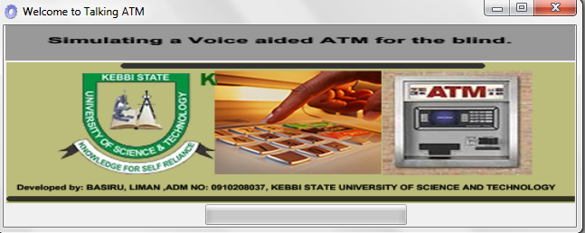

LOGIN CONSOLE
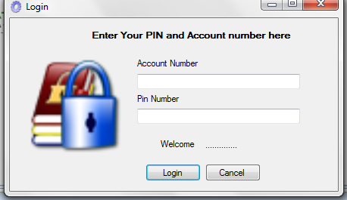

MAIN ATM FORM
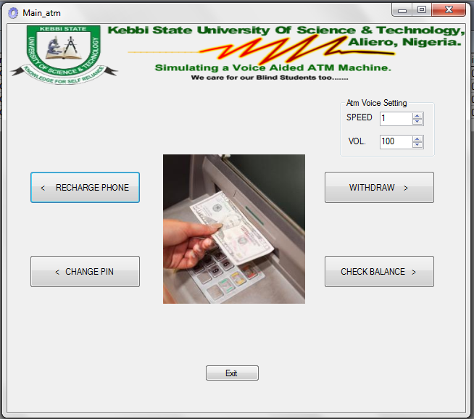

CASH DISPENSER FORM
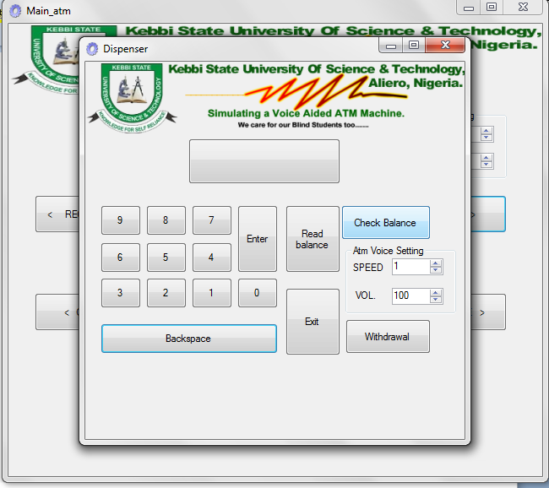

CHANGE PIN FORM
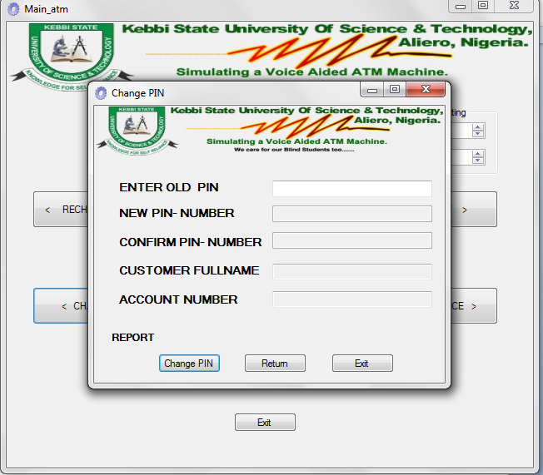

CUSTOMER INFORMATION DATABASE
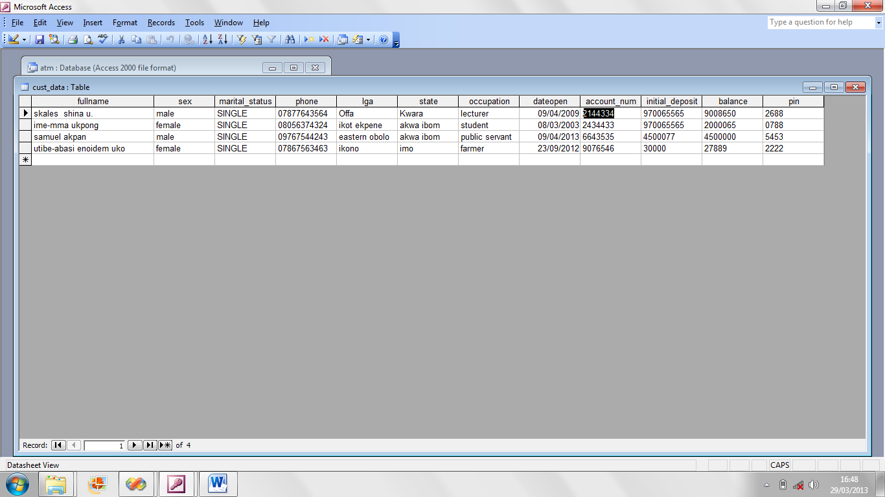

PIN NUMBER DATABASE
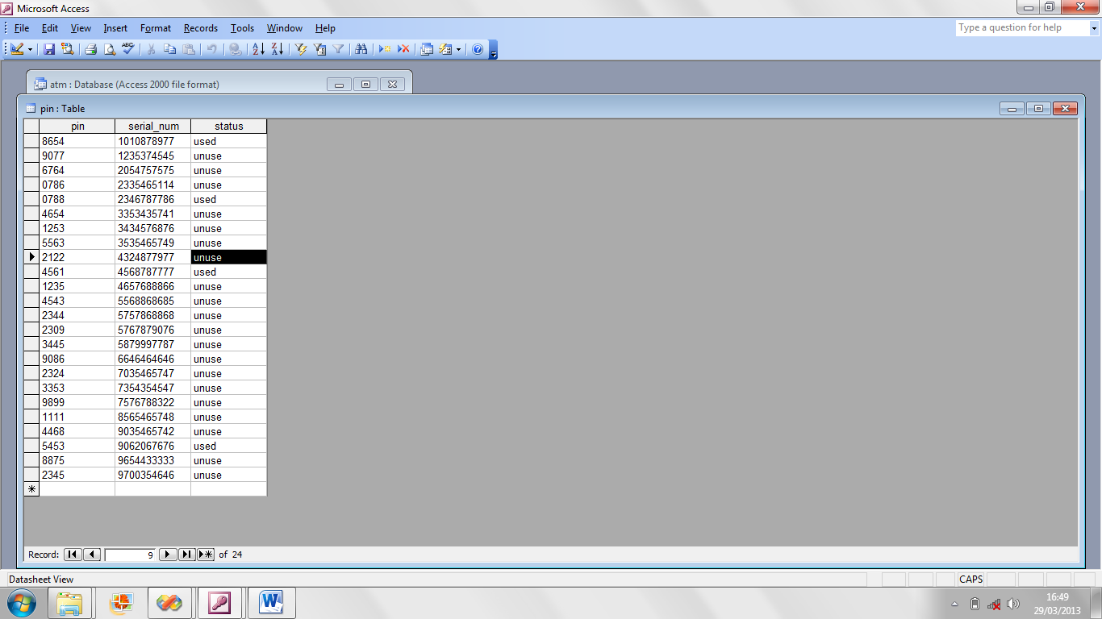
SOURCECODE (MICROSOFT VISUAL BASIC.NET 2008)
''''''''''''''''''''''''''''''''''''''
' 03/04/2013 '
' By Ndueso Walter '
' +2348067361023
' newleastpaysolution@gmail.com '
''''''''''''''''''''''''''''''''''''''
LOGIN FORM

Imports System.Data.OleDb
Imports System.Speech.Synthesis
Public Class Login
Dim speaker As New SpeechSynthesizer()
Private Sub OK_Click(ByVal sender As System.Object, ByVal e As System.EventArgs) Handles OK.Click
Try
Dim conn As OleDbConnection = NewConnection()
Dim command As New OleDbCommand("SELECT [account_num] FROM [cust_data] WHERE [account_num] = '" & Trim(account_num.Text) & "' AND [pin] = '" & Trim(pin.Text) & "'", conn)

Dim usernameParam As New OleDbParameter("username", Me.account_num.Text)
Dim passwordParam As New OleDbParameter("password", Me.pin.Text)

command.Parameters.Add(usernameParam)
command.Parameters.Add(passwordParam)

command.Connection.Open()
Dim reader As OleDbDataReader = command.ExecuteReader()
If reader.HasRows Then
MessageBox.Show("you are authenticated", "Successful")
Me.Hide()
Main_atm.Show()
Else
MessageBox.Show("Your Account Number of Pin number is not correct,Try again", "Login error")
Me.Show()
End If
command.Connection.Close()
welcome.Timer1.Enabled = False
Catch ex As Exception
End Try

'transfer account Number
Dim accountContents As String
accountContents = Me.account_num.Text
Main_atm.dis1.Text = accountContents
End Sub
Private Sub account_num_TextChanged(ByVal sender As System.Object, ByVal e As System.EventArgs) Handles account_num.TextChanged
Try
Dim conn As OleDbConnection = NewConnection()
' create a new command object
Dim cmd As OleDbCommand = New OleDbCommand(("select fullname FROM cust_data WHERE account_num ='" & Trim(account_num.Text) & " '"), conn)
conn.Open()
Dim sdr As OleDbDataReader = cmd.ExecuteReader()
While sdr.Read = True
Label3.Text = (sdr(0).ToString())
End While
sdr.Close()
conn = Nothing
Catch ex As Exception
End Try
End Sub
Private Function NewConnection() As OleDb.OleDbConnection
Dim ConnectionString = "Provider=Microsoft.Jet.OLEDB.4.0;Data Source=" & System.Environment.CurrentDirectory & "\atm.mdb"
Dim conn As New OleDb.OleDbConnection(ConnectionString)
Return conn
End Function
Private Sub Cancel_Click(ByVal sender As System.Object, ByVal e As System.EventArgs) Handles Cancel.Click
Application.Exit()
End Sub
Private Sub Login_Load(ByVal sender As System.Object, ByVal e As System.EventArgs) Handles MyBase.Load
Me.Left = (Screen.PrimaryScreen.WorkingArea.Width - Me.Width) / 2
Me.Top = (Screen.PrimaryScreen.WorkingArea.Height - Me.Height) / 2
speaker.Rate = Convert.ToInt32(txtspeed.Value)
speaker.Volume = Convert.ToInt32(txtvol.Value)
speaker.SpeakAsync("Welcome, Login here to Continue")
End Sub
End Class

CHANGE PIN FORM
Imports System.Data.OleDb
Imports System.Speech.Synthesis
Public Class pin
Dim response As Integer
Dim speaker As New SpeechSynthesizer()
Private Sub oldpin_TextChanged(ByVal sender As System.Object, ByVal e As System.EventArgs) Handles oldpin.TextChanged
Try
Dim conn As OleDbConnection = NewConnection()
' create a new command object
Dim cmd As OleDbCommand = New OleDbCommand(("select fullname,account_num FROM cust_data WHERE pin ='" & Trim(oldpin.Text) & " '"), conn)
conn.Open()
Dim sdr As OleDbDataReader = cmd.ExecuteReader()
While sdr.Read = True
custname.Text = (sdr(0).ToString())
accountnum.Text = (sdr(1).ToString())
End While
sdr.Close()
conn = Nothing
Catch ex As Exception
End Try
End Sub
Private Function NewConnection() As OleDb.OleDbConnection
Dim ConnectionString = "Provider=Microsoft.Jet.OLEDB.4.0;Data Source=" & System.Environment.CurrentDirectory & "\atm.mdb"
Dim conn As New OleDb.OleDbConnection(ConnectionString)
Return conn
End Function
Private Sub pin_Load(ByVal sender As System.Object, ByVal e As System.EventArgs) Handles MyBase.Load
Me.Left = (Screen.PrimaryScreen.WorkingArea.Width - Me.Width) / 2
Me.Top = (Screen.PrimaryScreen.WorkingArea.Height - Me.Height) / 2
newpin.Enabled = False
confirmpin.Enabled = False
End Sub
Private Sub accountnum_TextChanged(ByVal sender As System.Object, ByVal e As System.EventArgs) Handles accountnum.TextChanged
If accountnum.Text <> "" Then
newpin.Enabled = True
confirmpin.Enabled = True
End If
End Sub
Private Sub button2_Click(ByVal sender As System.Object, ByVal e As System.EventArgs) Handles button2.Click
Me.Close()
End Sub
Private Sub button1_Click(ByVal sender As System.Object, ByVal e As System.EventArgs) Handles button1.Click
If newpin.Text <> confirmpin.Text Then
speaker.Rate = Convert.ToInt32(txtspeed.Value)
speaker.Volume = Convert.ToInt32(txtvol.Value)
speaker.SpeakAsync("Your Pin Numbers are not compatible")
Label3.Text = ("Your Pin Numbers are not compatible")
ElseIf newpin.Text = confirmpin.Text Then

Dim DBUpdate As New OleDbCommand
Dim connection As OleDbConnection = NewConnection()
DBUpdate.CommandText = "UPDATE [cust_data] SET " & _
"[pin] = '" & confirmpin.Text & "'" & _
"WHERE account_num = '" & accountnum.Text & "' AND pin = '" & oldpin.Text & "'"

DBUpdate.Connection = connection
DBUpdate.Connection.Open()
response = DBUpdate.ExecuteNonQuery()

connection.Close()
connection.Dispose()
End If
End Sub
Private Sub Button3_Click(ByVal sender As System.Object, ByVal e As System.EventArgs) Handles Button3.Click
Me.Hide()
Main_atm.Show()
End Sub
Private Sub confirmpin_TextChanged(ByVal sender As System.Object, ByVal e As System.EventArgs) Handles confirmpin.TextChanged
End Sub
End Class

WITHDRAWAL FORM
Imports System.Speech.Synthesis
Public Class Main_atm
Dim speaker As New SpeechSynthesizer()
Private Sub Button2_Click(ByVal sender As System.Object, ByVal e As System.EventArgs) Handles Button2.Click
Dim accountContents As String
accountContents = Me.dis1.Text
Dispenser.dis.Text = accountContents
Dispenser.Show()
End Sub
Private Sub Main_atm_Load(ByVal sender As System.Object, ByVal e As System.EventArgs) Handles MyBase.Load

speaker.Rate = Convert.ToInt32(txtspeed.Value)
speaker.Volume = Convert.ToInt32(txtvol.Value)
speaker.SpeakAsync("Welcome to our Voice aided atm, a research project by Basiru Liman")
End Sub
Private Sub Button5_Click(ByVal sender As System.Object, ByVal e As System.EventArgs) Handles Button5.Click
Application.Exit()
End Sub
Private Sub Button4_Click(ByVal sender As System.Object, ByVal e As System.EventArgs) Handles Button4.Click
pin.Show()
End Sub
Private Sub Button3_Click(ByVal sender As System.Object, ByVal e As System.EventArgs) Handles Button3.Click
Dim accountContents As String
accountContents = Me.dis1.Text
Dispenser.dis.Text = accountContents
Dispenser.Show()
End Sub
End Class

CHECK BALANCE FORM
Imports System.Speech.Synthesis
Public Class Main_atm
Dim speaker As New SpeechSynthesizer()
Private Sub Button2_Click(ByVal sender As System.Object, ByVal e As System.EventArgs) Handles Button2.Click
Dim accountContents As String
accountContents = Me.dis1.Text
Dispenser.dis.Text = accountContents
Dispenser.Show()
End Sub
Private Sub Main_atm_Load(ByVal sender As System.Object, ByVal e As System.EventArgs) Handles MyBase.Load
speaker.Rate = Convert.ToInt32(txtspeed.Value)
speaker.Volume = Convert.ToInt32(txtvol.Value)
speaker.SpeakAsync("Welcome to our Voice aided atm, a research project by Basiru Liman")
End Sub
Private Sub Button5_Click(ByVal sender As System.Object, ByVal e As System.EventArgs) Handles Button5.Click
Application.Exit()
End Sub
Private Sub Button4_Click(ByVal sender As System.Object, ByVal e As System.EventArgs) Handles Button4.Click
pin.Show()
End Sub
Private Sub Button3_Click(ByVal sender As System.Object, ByVal e As System.EventArgs) Handles Button3.Click
Dim accountContents As String
accountContents = Me.dis1.Text
Dispenser.Text = accountContent
Dispenser.Show()
End Sub
End Class

CHAPTER FIVE
SUMMARY, RECOMMENDATION AND CONCLUSION
- INTRODUCTION
This chapter primarily present a concise summary of the entire study, the recommendation to improve the proposed system to meet future expectation of the system developers and users.
5.1 SUMMARY
ATM stands for Automated teller machine. Presently this is one of the most improvised ways of transaction in Modern banking around the world today. As people do not feel comfortable to carry huge amount of money, they use ATMs. By adding new features and also increasing the security issues like adding voice aided assistant to the system, it may provide more efficiency, comfort and supremacy to all types of customer i.e. Able and blind customer than it today. As a result transaction becomes reliable and lightens up. Here in this paper we tried to give a full description, how ATM works and comparisons among the ATM services. We also tried to focus few problems and few suggestions how to eliminate these problems.
Apart from withdrawing cash , ATM perform others functions such as Deposit currency recognition, acceptance, and recycling, Paying routine bills, fees, and taxes (utilities, phone bills, social security, legal fees, taxes, etc.) ,Printing bank statements, Updating passbooks and crediting of cell phones.
Talking ATMS are automatic teller machines that provide the ability to conduct transactions using both visual and auditory components. Essentially, a talking ATM will provide a means of persons with visual impairments to utilize the ATM by making use of audible instructions. While many ATMs today include an audio component that makes use of a speaker system, the talking ATM employs the feature of a headphone jack or telephone handset that allows the user to conduct the transaction with a degree of security.
5.2 CONCLUSION
This project has been completed with a great success of understanding of ATM (Automated Teller Machine) full working process. We basically give more emphasis on the real time infrastructure of how a voice aided ATMs can be useful for enhance ATM access to visually impair customer of the bank. The climax of this project is the simulation of a voice aided ATM that provide the ability to conduct transactions using both visual and auditory components by making use of audible instructions. At the end we come with a conclusion that what we have read and how it works in live situation are totally different from our expectation. Our project paper has been written with a contrast with both sides from the bookish knowledge and real time experience.
5.3 RECOMMENDATION
Recommendations are provided to promote acceptability, integrity, security and more importantly enhance ATM access to blind customer. Besides recommending a voice aided ATM system to enhance better ATM and banking services, Nigerian Banks should also integrate a biometric system to the Talking ATM to ensure security of customer’s money. To ensure that blind customer are not defraud, banks security should ensure that those on similar transaction on the queue are far away from where they are doing transaction with ATM machine. Also such customers should not fail to come to bank with a trusted person to assist them. When implementing the voice aided or talking ATM, banks should make sure that there is steady power supply to power the ATM and a headphone jack or telephone handset to allow the user to conduct the transaction with a degree of security.

